Enquiry

TC_038

Ensure users can select state, city, and branch and submit the enquiry successfully

1. Navigate to the Admission Enquiry page  
2. Select a State from the dropdown  
3. Select a City from the dropdown  
4. Select a Branch from the dropdown  
5. Click on Send Enquiry button

Working as expected

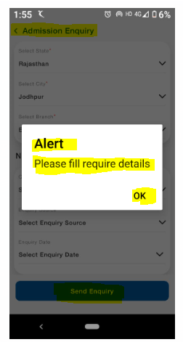

TC_039

Ensure users cannot submit the form without selecting required fields

1. Navigate to the Admission Enquiry page  
2. Do not select any state, city, or branch  
3. Click on Send Enquiry

Working as expected

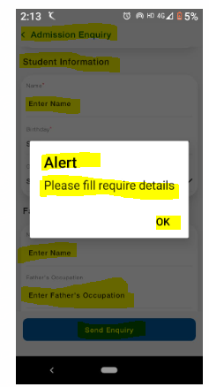

TC_040

Ensure the city dropdown updates based on the selected state and the branch dropdown updates based on the selected city

1. Navigate to the Admission Enquiry page  
2. Select a state from the dropdown  
3. Check if only relevant cities appear in the city dropdown  
4. Select a city and verify if only relevant branches appear

The dropdown options is linked correctly

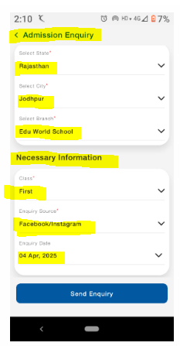

TC_041

Ensure users cannot click the Send Enquiry button until all required fields are filled

1. Navigate to the Admission Enquiry page  
2. Observe the Send Enquiry button before selecting any field  
3. Select a state, but do not select a city/branch  
4. Check if the button remains disabled  
5. Select all fields and check if the button becomes enabled

The **Send Enquiry** button is remain enabled until all required fields are selected

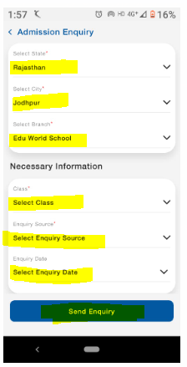

TC_042

Ensure users cannot submit the form without selecting required fields

1. Navigate to the Admission Enquiry page  
2. Do not select any state, city, or branch  
3. Click on Send Enquiry

Working as expected

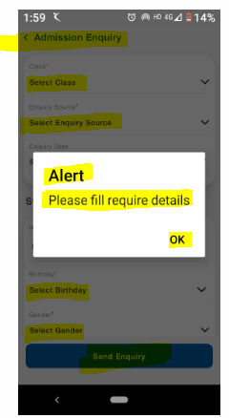

TC_043

Ensure the form layout is properly aligned and responsive on different screen sizes

1. Open the form on various screen sizes (mobile, tablet)  
2. Check alignment of dropdowns and the Send Enquiry button  
3. Resize the screen and check UI adjustments

The form should be properly aligned, and elements should adjust based on screen size

TC_044

Ensure form handles network disconnection gracefully

1. Open the **Admission Enquiry** form

2. Select all required fields

3. Turn off internet connection

4. Click **Send Enquiry**

Working as expected

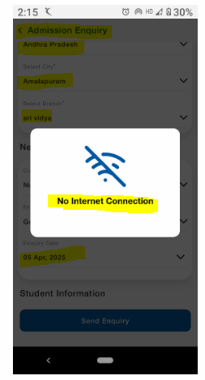

TC_045

Ensure users cannot select City or Branch without selecting a State first

1. Open the Admission Enquiry page  
2. Try selecting City without selecting State  
3. Try selecting Branch without selecting City

Working as expected

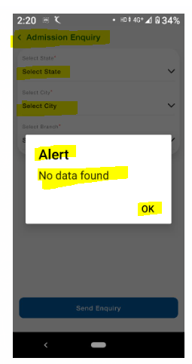

TC_046

Ensure the form functions correctly when multiple users submit at the same time

1. Simulate 100+ concurrent users submitting the form  
2. Observe response time and server performance

The form should remain responsive and not crash

TC_047

Ensure the form loads within an acceptable time range under different network speeds

1. Load the Admission Enquiry form with a fast internet connection  
2. Load the same form on a slow 3G network  
3. Measure the loading time

The form should load within **2-3 seconds** under a normal connection and **5 seconds** under a slow connection

TC_048

Ensure the app does not crash due to high memory usage while interacting with the form

1. Open the Admission Enquiry form  
2. Switch between multiple apps while keeping the form open  
3. Observe memory consumption and check if the form crashes

Working as expected

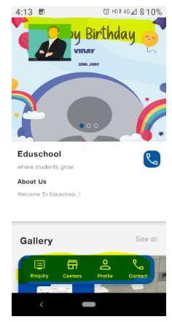

TC_049

Ensure unauthorized users cannot access or modify the form data via API

1. Open Developer Tools (F12)  
2. Identify the API request when submitting the form  
3. Modify the request and try submitting unauthorized data

The system should reject unauthorized API requests

TC_050

Ensure the system prevents excessive form submissions

1. Use a script to submit the Admission Enquiry form multiple times (100+ requests in a minute)  
2. Observe if the server blocks excessive requests

The system should block or throttle excessive requests

TC_051

1. Log in to the application  
2. Stay inactive for 15-20 minutes  
3. Try to submit the Admission Enquiry form

The system should log out the user and prevent form submission

The system is not log out the user

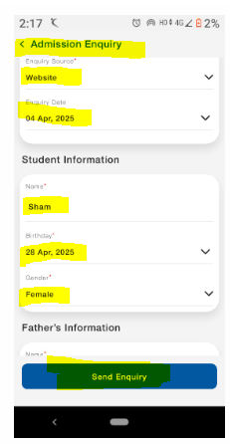

TC_052

Ensure users can easily select values from dropdowns (State, City, Branch)

1. Open the Admission Enquiry form  
2. Click on the State dropdown and select an option  
3. Click on the City dropdown and select an option  
4. Click on the Branch dropdown and select an option  
5. Click Send Enquiry

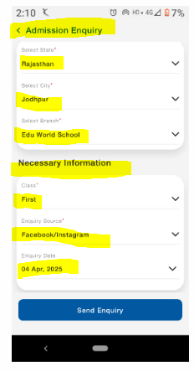

TC_053

Ensure users can complete the form within a reasonable time

1. Open the Admission Enquiry form  
2. Start a timer and complete the form by selecting values from dropdowns  
3. Click Send Enquiry  
4. Stop the timer and record the time taken

The form should be quick and easy to fill

TC_054

Ensure proper validation messages appear when required fields are left empty

1. Open the Admission Enquiry form  
   2. Click Send Enquiry without selecting any values  
   3. Verify if error messages are displayed for required fields

System displayed error message

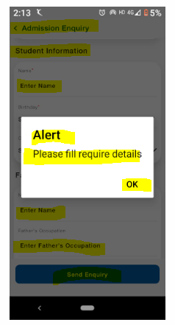

TC_055

Ensure the **Send Enquiry** button is easy to click on all devices

1. Open the Admission Enquiry form  
2. Try clicking on the Send Enquiry button on a mobile device and desktop  
3. Observe if the button is responsive

The button should respond immediately when clicked

TC_056

Ensure users receive a confirmation message after submitting the form

1. Fill out the complete form  
2. Click Send Enquiry  
3. Verify if a success message appears

A message like **"Your enquiry has been submitted successfully"** should appear

TC_057

Ensure the Student Information dropdown works correctly

1. Open the Admission Enquiry form  
2. Select Name, Birthday and Gender

The selected source is not displaying properly

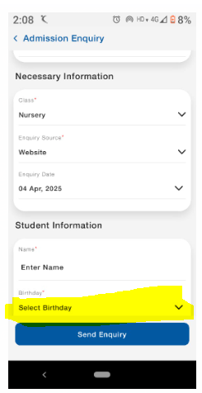

TC_058

Ensure users can select a class from the dropdown list

1. Open the Admission Enquiry form  
2. Click on the Class dropdown  
3. Select a class from the available options

Working as expected

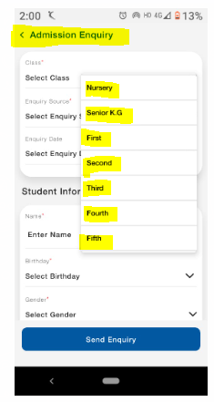

TC_059

Ensure the "Necessary Information" dropdown works correctly

1. Open the Admission Enquiry form  
2. Select Class, Enquiry Source and Enquiry date

The selected source is not displaying properly

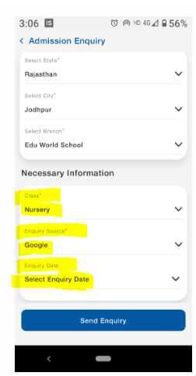

TC_060

Ensure users can select a date from the date picker

1. Click on the Enquiry Date field  
2. Select a date from the calendar picker

The date is not displayed

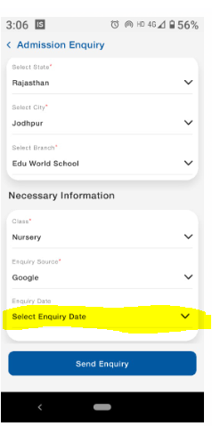

TC_061

Ensure users can enter a valid name in the input field

1. Click on the Name field  
2. Enter a valid name (e.g., "Ram")

working as expected

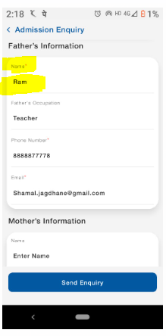

TC_062

Ensure users can select a valid birthday using the date picker

1. Click on the Birthday field  
2. Select a valid date from the picker

The "Birthday" field is not working regularly

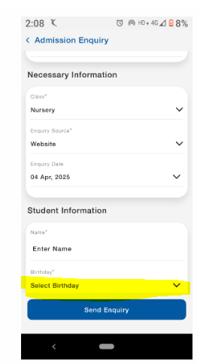

TC_063

Ensure users can select a gender from the dropdown

1. Click on the Gender dropdown  
2. Select Male or Female or Other

Working as expected

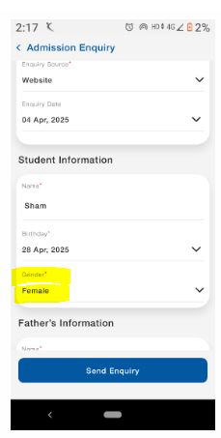

TC_064

Ensure the **Send Enquiry** button submits the form correctly

1. Fill in all required fields  
2. Click on Send Enquiry

The form should submit and show a success message

TC_065

Ensure form cannot be submitted without filling required fields

1. Open the form  
2. Click Send Enquiry without entering/selecting any data  
3. Observe validation messages

Working as expected

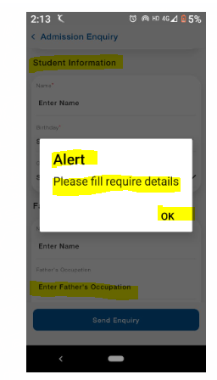

TC_066

Ensure the name field does not accept numbers or special characters

1. Enter "John123!@" in the Name field  
2. Click Send Enquiry

Error message should appear: "Name should contain only alphabets"

TC_067

Ensure users cannot select a future birth date

1. Click Birthday field  
2. Select a date in the future (e.g., 2030-05-12)  
3. Click Send Enquiry

The "Birthday" field is not working

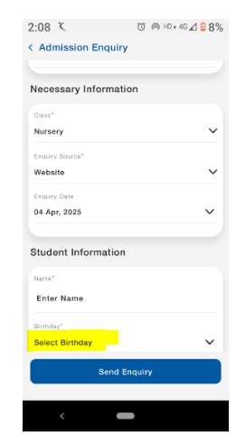

TC_068

Ensure the form does not submit with empty required fields

1. Open the Father's Information form  
2. Leave all fields empty  
3. Click Submit

Working as expected

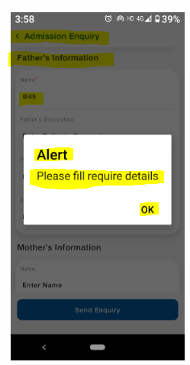

TC_069

Ensure the phone number field accepts only valid formats

1. Enter "Abc1234567" in the Phone Number field  
2. Click Submit

Error message: **"Invalid phone number" is not displaying**

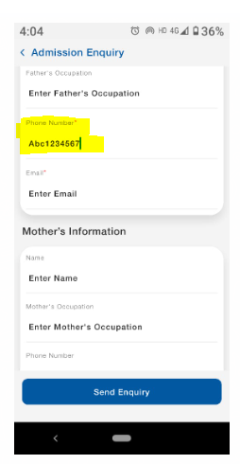

TC_070

Ensure users cannot enter less than 10 digits in the phone number field

1. Enter "98765" in the Phone Number field  
2. Click Submit

Error message: "Phone number must be 10 digits" is not displaying

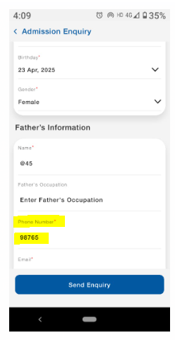

TC_071

Ensure users cannot enter more than 10 digits in the phone number field

1. Enter **"9876543210987"** in the **Phone Number** field

Error message: **"Phone number must be 10 digits" is not displaying**

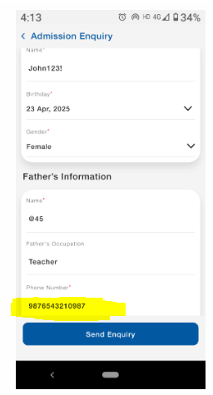

TC_072

Ensure the email field accepts only valid email formats

1. Enter "fathername.gmail.com" in the Email field  
2. Click Submit

Error message: **"Invalid email format" is not displaying**

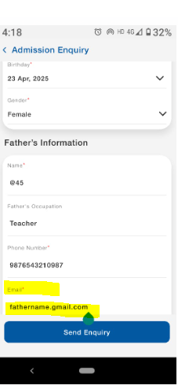

TC_073

Ensure the form submits successfully with valid data

1. Enter "John Dole" in Name  
2. Enter "Engineer" in Father's Occupation  
3. Enter "9876543210" in Phone Number  
4. Enter "john.dole@email.com" in Email  
5. Click Submit

The form should submit successfully without errors

TC_074

Ensure the **Name** field accepts valid input

1. Enter "Neha" in the Name field  
2. Click Submit

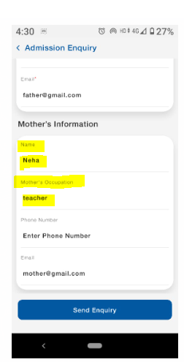

TC_075

Ensure the **Mother’s Occupation** field accepts a valid job title

1. Enter "Teacher" in the Mother’s Occupation field  
2. Click Submit

Working as expected



